Project Design Phase-II
Data Flow Diagram & User Stories

Date | 30 September 2026
Team ID | SWTID-2026-4912
Project Name | AI WeatherWise
Maximum Marks | 4 Marks

Data Flow Diagrams:
A Data Flow Diagram (DFD) is a traditional visual representation of the information flows within a system. A neat and clear DFD can depict the right amount of the system requirement graphically. It shows how data enters and leaves the system, what changes the information, and where data is stored.

Data Flow Diagram (Level 1): AI WeatherWise
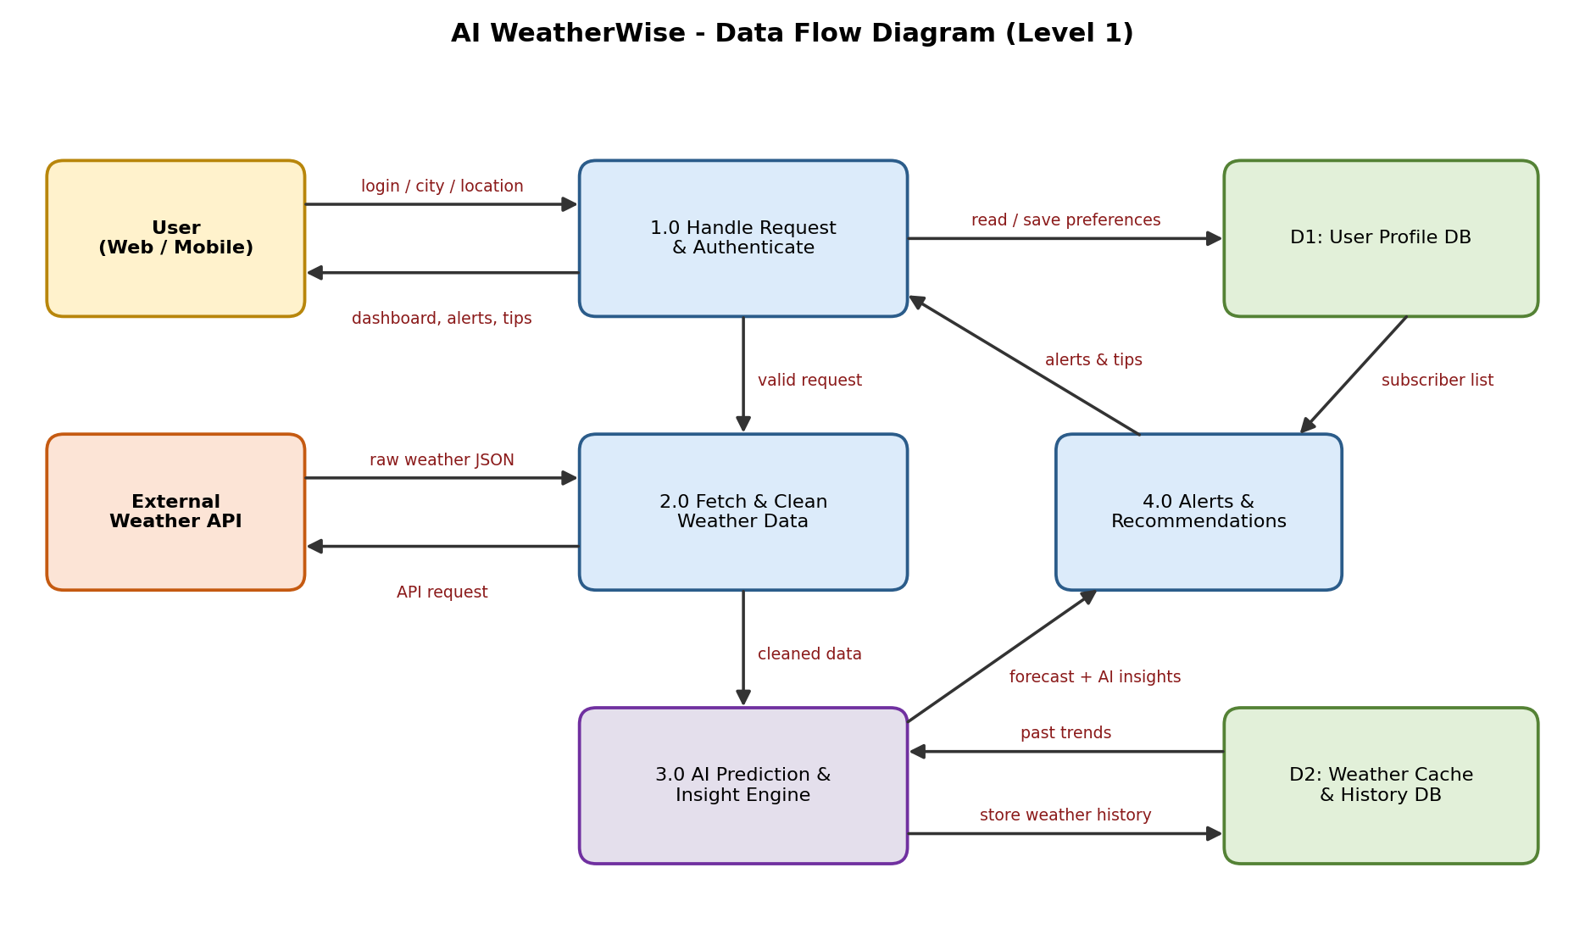

User Stories
Use the below template to list all the user stories for the product.
User Type | Functional Requirement (Epic) | User Story Number | User Story / Task | Acceptance criteria | Priority | Release
Customer (Web user) | Registration | USN-1 | As a user, I can register for the application by entering my name, email, password, and confirming my password. | I can create an account and access my dashboard | High | Sprint-1
Customer (Web user) | Registration | USN-2 | As a user, I will receive a confirmation email once I have registered for the application. | I receive the confirmation email and can click the link to confirm | High | Sprint-1
Customer (Web user) | Login | USN-3 | As a user, I can log into the application by entering my email & password. | I can log in and see my personal dashboard | High | Sprint-1
Customer (Web user) | Weather Search | USN-4 | As a user, I can search the weather of any city by typing its name. | Weather of the searched city is displayed within 3 seconds | High | Sprint-1
Customer (Mobile user) | Weather Search | USN-5 | As a mobile user, I can let the app detect my current location automatically. | After I allow location access, local weather is displayed | Medium | Sprint-1
Customer (Web user) | Current Weather Dashboard | USN-6 | As a user, I can view the current temperature, humidity, wind speed, pressure and visibility on the dashboard. | All parameters are displayed with clear icons | High | Sprint-1
Customer (Web user) | Current Weather Dashboard | USN-7 | As a user, I can switch between Celsius and Fahrenheit. | All values convert instantly without page reload | Medium | Sprint-1
Customer (Web user) | Forecast | USN-8 | As a user, I can view the hourly forecast for the next 24 hours. | An hourly chart / list is displayed for the selected city | High | Sprint-2
Customer (Web user) | Forecast | USN-9 | As a user, I can view the 7-day forecast. | Seven day cards with min/max temperature and condition are shown | High | Sprint-2
Customer (Web user) | Forecast | USN-10 | As a user, I can see the Air Quality Index (AQI) of my city. | AQI value and category (Good / Moderate / Poor) are displayed | Medium | Sprint-2
Customer (Web user) | Weather API Integration | USN-11 | As a user, I get weather results quickly because recent weather data is cached by the system. | A repeated search within 10 minutes loads in under 1 second | High | Sprint-2
Customer (Web user) | Favourite Cities | USN-12 | As a user, I can save my favourite cities. | Saved cities appear on my dashboard and can be removed | Medium | Sprint-2
Customer (Web user) | AI Insights | USN-13 | As a user, I can read an AI-generated plain-language summary of today's weather. | A 2-3 sentence easy-to-understand summary is displayed | High | Sprint-3
Customer (Web user) | AI Insights | USN-14 | As a user, I can see the rain probability predicted by AI for the next few hours. | Rain probability (%) is displayed with a confidence label | High | Sprint-3
Customer (Web user) | AI Insights | USN-15 | As a user, I receive personalised clothing and travel tips based on the weather. | Tips shown match the current weather conditions | Medium | Sprint-3
Customer (Web user) | Weather History | USN-16 | As a user, I can view a trend chart of past weather data of my city. | A chart of the last 7 days is displayed | Low | Sprint-3
Customer (Web user) | Alerts & Notifications | USN-17 | As a user, I receive email alerts for severe weather such as heavy rain, storm or heat wave. | Email is received within 5 minutes of the alert condition | High | Sprint-4
Customer (Mobile user) | Alerts & Notifications | USN-18 | As a mobile user, I receive a daily morning weather briefing. | Briefing is delivered at the time chosen by me | Medium | Sprint-4
Administrator | Administration | USN-19 | As an administrator, I can view registered users and API usage logs. | Admin dashboard lists users, API calls and error logs | Low | Sprint-4
Customer (Web user) | User Interface | USN-20 | As a user, I can use dark mode and a layout that fits my phone, tablet and desktop. | UI adapts to all screen sizes and theme can be toggled | Medium | Sprint-4
Customer (Web user) | Testing & Deployment | USN-21 | As a user, I can access a stable, tested application online at any time. | Application is deployed on cloud and UAT is passed | High | Sprint-4

